Base Model Hyper Parametrer tuning
Decision Tree
index | criterion | max_depth
0 | gini | 21
1 | entropy | 7
2 | entropy | 13
3 | gini | 13
4 | gini | 4
5 | gini | 6
6 | entropy | 13
7 | entropy | 22
8 | gini | 2
9 | gini | 2
10 | entropy | 15
11 | entropy | 4
12 | gini | 9
13 | entropy | 17
14 | gini | 13
15 | entropy | 13
16 | entropy | 16
17 | gini | 2
18 | gini | 15
19 | gini | 12
20 | gini | 20
21 | gini | 19
22 | gini | 2

K-NN
index | metric | n_neighbors
0 | euclidean | 3
1 | manhattan | 3
2 | manhattan | 3
3 | euclidean | 3
4 | euclidean | 5
5 | manhattan | 9
6 | euclidean | 3
7 | manhattan | 3
8 | manhattan | 5
9 | manhattan | 3
10 | manhattan | 3
11 | euclidean | 3
12 | manhattan | 3
13 | manhattan | 3
14 | euclidean | 3
15 | euclidean | 3
16 | manhattan | 5
17 | euclidean | 3
18 | euclidean | 11
19 | manhattan | 11
20 | manhattan | 3
21 | manhattan | 3
22 | euclidean | 3
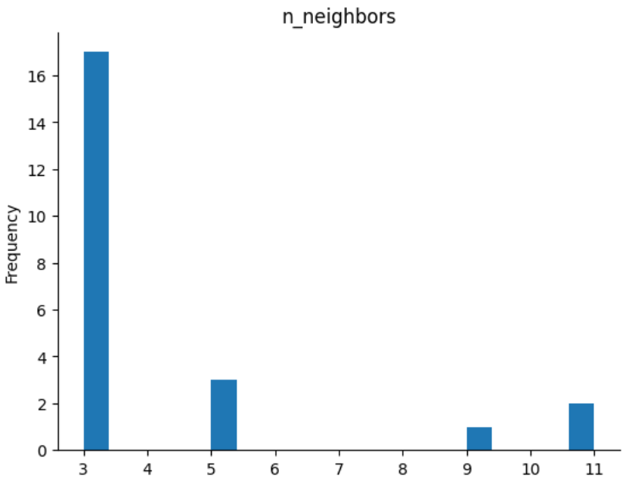

Logistic Regression
index | C | max_iter | multi_class | random_state | solver
0 | 1000.0 | 100 | auto | null | liblinear
1 | 10.0 | 100 | auto | null | liblinear
2 | 100.0 | 100 | auto | null | liblinear
3 | 1.0 | 100 | auto | null | liblinear
4 | 1000.0 | 100 | auto | null | liblinear
5 | 0.1 | 100 | auto | null | liblinear
6 | 100.0 | 100 | auto | null | liblinear
7 | 10.0 | 100 | auto | null | liblinear
8 | 1000.0 | 100 | auto | null | liblinear
9 | 0.01 | 100 | auto | null | liblinear
10 | 1000.0 | 100 | auto | null | liblinear
11 | 10.0 | 100 | auto | null | lbfgs
12 | 100.0 | 100 | auto | null | liblinear
13 | 0.1 | 100 | auto | null | liblinear
14 | 1000.0 | 100 | auto | null | liblinear
15 | 1000.0 | 100 | auto | null | lbfgs
16 | 10.0 | 100 | auto | null | liblinear
17 | 100.0 | 100 | auto | null | liblinear
18 | 10.0 | 100 | auto | null | liblinear
19 | 100.0 | 100 | auto | null | lbfgs
20 | 1000.0 | 100 | auto | null | liblinear
21 | 100.0 | 100 | auto | null | liblinear
22 | 10.0 | 100 | auto | null | Liblinear

- C : Inverse of regularization strength; smaller values specify stronger regularization.

- class_weight : Weights associated with classes in the form {class_label: weight}.

- max_iter : Maximum number of iterations taken for the solvers to converge.

- multi_class : If the option chosen is 'ovr', then a binary problem is fit for each label. If 'multinomial', the loss minimised is the multinomial loss fit across the entire probability distribution, even when the data is binary.

- solver : Algorithm to use in the optimization problem ('newton-cg', 'lbfgs', 'liblinear', 'sag', 'saga').
SVM

index | C | coef0 | degree | gamma | kernel
0 | 41 | 0.001 | 3 | scale | rbf
1 | 31 | 0.001 | 3 | scale | rbf
2 | 41 | 0.001 | 3 | scale | rbf
3 | 11 | 0.001 | 3 | scale | rbf
4 | 1 | 0.001 | 4 | scale | poly
5 | 1 | 1.001 | 5 | auto | poly
6 | 41 | 0.001 | 3 | scale | rbf
7 | 21 | 0.001 | 3 | scale | rbf
8 | 41 | 0.001 | 3 | scale | rbf
9 | 1 | 0.001 | 4 | scale | poly
10 | 31 | 0.001 | 3 | scale | rbf
11 | 21 | 0.001 | 3 | scale | rbf
12 | 1 | 1.501 | 3 | scale | poly
13 | 11 | 1.501 | 3 | scale | poly
14 | 1 | 0.501 | 5 | scale | poly
15 | 21 | 0.001 | 3 | scale | rbf
16 | 21 | 2.501 | 3 | auto | poly
17 | 21 | 2.501 | 5 | auto | poly
18 | 31 | 0.001 | 3 | auto | linear
19 | 31 | 0.001 | 3 | scale | rbf
20 | 31 | 0.001 | 3 | scale | rbf
21 | 11 | 0.001 | 3 | scale | rbf
22 | 31 | 0.001 | 3 | scale | rbf

This table appears to show parameters for different instances of a Support Vector Machine (SVM) model. Each row represents a different configuration of the SVM model, and the columns indicate the values of various parameters:

1. index : An identifier for each configuration.
2. C : Regularization parameter. It controls the trade-off between having a smooth decision boundary and classifying the training points correctly.
3. coef0 : Independent term in the kernel function. It affects the influence of high-degree polynomials on the decision boundary.
4. degree : Degree of the polynomial kernel function.
5. gamma : Kernel coefficient. It defines how far the influence of a single training example reaches.
6. kernel : Type of kernel function used ('linear', 'poly', 'rbf', 'sigmoid', etc.).
Naïve Bayes
index | kernel | max_iter_predict | multi_class
0 | RBF | 100 | one_vs_rest
1 | RBF | 100 | one_vs_rest
2 | RBF | 100 | one_vs_rest
3 | RBF | 100 | one_vs_rest
4 | RBF | 100 | one_vs_rest
5 | RBF | 100 | one_vs_rest
6 | RBF | 100 | one_vs_rest
7 | RBF | 100 | one_vs_rest
8 | RBF | 100 | one_vs_rest
9 | RBF | 100 | one_vs_rest
10 | RBF | 100 | one_vs_rest
11 | RBF | 100 | one_vs_rest
12 | RBF | 100 | one_vs_rest
13 | RBF | 100 | one_vs_rest
14 | RBF | 100 | one_vs_rest
15 | RBF | 100 | one_vs_rest
16 | RBF | 100 | one_vs_rest
17 | RBF | 100 | one_vs_rest
18 | RBF | 100 | one_vs_rest
19 | RBF | 100 | one_vs_rest
20 | RBF | 100 | one_vs_rest
21 | RBF | 100 | one_vs_rest
22 | RBF | 100 | one_vs_rest

This table appears to show configurations for a machine learning model using a Support Vector Machine (SVM) with an RBF (Radial Basis Function) kernel. Here's an explanation of the columns:

1. index : An identifier for each configuration.
3. kernel : The type of kernel function used, in this case, RBF.
4. max_iter_predict : Maximum number of iterations for prediction.
5. multi_class : Method for handling multiple classes, typically 'one_vs_rest' which stands for one-vs-the-rest strategy where each class is considered separately against all other classes.

Frozen layers analysis- Sensitivity
arch | NN | SVM | LR | KNN | NB
1 Layer Frozen | 0.373058 | 0.526911 | 0.548421 | 0.558063 | 0.535231
2 Layer Frozen | 0.437753 | 0.46363 | 0.486737 | 0.480846 | 0.435719
3 Layer Frozen | 0.373058 | 0.423264 | 0.449134 | 0.474576 | 0.396751
All Layers Frozen | 0.437753 | 0.434985 | 0.440231 | 0.491432 | 0.403402
All Layers Unfrozen | 0.537753 | 0.605724 | 0.623221 | 0.651528 | 0.627602

